What is Exploratory Data Analysis

Edris Safari

Bellevue University, Nebraska U.S.A.

Abstract

Exploratory Data Analysis was coined by John W. Tukey, who wrote the book Exploratory Data Analysis in 1977. It has been widely known and accepted that it is an essential part of any data science project. Methodologies such as the CRISP-DM, SEMMA , JTA, and others highlight the necessity of EDA in any data science project. This paper offers a brief description of the process of data exploration and its role in a data science project. It will present a use case example of a data mining exercise that aims to evaluate the efficacy of independent variables in the designated model.

Keywords: CRISP-DM,SEMMA,JTA,EDA

What is Exploratory Data Analysis

# Introduction

In the discussion of data science, the terms Machine Learning, and Data Mining are used interchangeably and often in the same sentence. The words probability & statistics, algorithms, and various algorithm techniques are also widely used in data science discussions. The bottom line for any data science project is that it should produce and answer to a question. The answer should add value to the questioner who posed the question in the first place. The questions are typically asked in a meeting room filled with executives, managers and directors. These people monitor the heartbeat of their organization by reviewing data and coming up with new ways of collecting data. Data collection and data analysis are heart and sole of a data science project. It is mostly these two activities that inspire questions such as how we can improve customer retention at our bank. Sometimes questions are asked without having looked at data. These questions are based on anecdotal evidence-a hearsay. An example given by Allen Downey is that first babies tend to arrive late, or my favorite one down here in Texas is that Sage bushes blossom before rainy days.

With the advent of the computer technology combined with a rich history of mathematical advancements, we now live in an era that we can create and utilize massive amount of data that we can pose and answer questions related to improving anything in any domain as long as we collect the correct data, and analyze it in a way that yield accurate results. This makes the role of data analysis and more specifically exploratory data analysis of paramount importance in the field of data science-at least for the time being.

The analysis of data or the exploration of data involves statistics at all levels of exploration process. The visualization of data comes at the very beginning of the process and may be repeated a few times. It allows the person with “trained eyes” and the person with expertise in the domain of data to summarize, compare and interpret the data. The person with domain knowledge can suggest which variables to include or exclude from the algorithm, and the “trained eye” person can create a visual effect such as a bar chart showing the percentage of customer who left vs those who stayed.

In the next two sections, we present two activities in the EDA process, visualization and quantitative analysis of data pertaining to a bank’s churn rate.

# Data Visualization

This use case explores a data set composed of 10,000 records. The goal is to determine what impacts a customer’s decision to stay with the bank. Is it their sex, age, number of product they have with the bank, or is it geography or salary or whether they have a credit card. As shown below, the ‘exited’ column in this dataset is regarded as the dependent variable which is the subject of this analysis, and the rest of the variables are the regressors or independent variables.

View Data: 
10,000 rows 
Customer Id 
15634602 
15647311 
15619304 
15701354 
15737888 
15574012 
15592531 
15656148 
15792365 
15592389 
15767821 
15737173 
Churn Modelling (P12-Churn Modelling) 
Show aliases 
x 
Dataset 
Exi ted 
Exi ted 
Stayed 
Exi ted 
Stayed 
Stayed 
Exited 
Stayed 
Exi ted 
Stayed 
Stayed 
Stayed 
Stayed 
Gender 
Female 
F emale 
F emale 
Female 
F emale 
Male 
Male 
F emale 
Male 
Male 
Male 
Male 
Geogr aph y 
France 
Spain 
Fr ance 
France 
Spain 
Spain 
Fr ance 
German y 
Fr ance 
Fr ance 
Fr ance 
Spain 
Has Cr Card 
Is Active Member 
Num Of Products 
Ron Number 
Surname 
Hargr ave 
5 Mitchell 
Bartlett 
10 
Il 
Bear ce 
Andrews 
12 
Age 
41 
42 
43 
44 
29 
44 
27 
31 
Balance 
0.00 
83,807.86 
159,660.80 
0.00 
125,510.82 
113,755.78 
0.00 
115,046.74 
142,051.07 
134,603.88 
102,016.72 
0.00 
Credit Score 
Estima ted Salar y 
101,348.88 
112,542.58 
113,931.57 
93,826.63 
79,084.10 
149,756.71 
10,062.80 
119,346.88 
74, 50 
71,725.73 
80,181.12 
76,390.01 
Number of Records 
Tenure 

Table - Dataset

The data visualization process will attempt to find correlation between independent variable. In the picture below, Tableau shows the bar chart of male and female customers with the percentage of those who stayed and exited. The graph shows that more females exited than males. The chi-squared analysis from <http://www.evanmiller.org/ab-testing/chi-squared.html> that Gender in this analysis pertinent. In Figure 2, replacing Gender with ‘Has Credit Card’ shows that this column does not contribute to the analysis. This analysis is preliminary. Perhaps “Has Credit Card” in combination with another independent variable(s) would be better fit for the model. This is the exercise that keeps the data analysis pinned to their desks!

Pages 
Filters 
Ma rks 
000 Automatic 
15.5%- 17.5% 
iii Columns 
Rows 
Gender 
Gender 
SUM(Number of Rec„ 
Actuals 
Gender 
Evan's Awesome AB Tools (home): 
Sample Size Calculator Chi-Squared Test Sequential Sampling 2 Sample T-Test Survival Times 
Question: Does the rate of success differ across two groups? 
Count Data 
z 
ssoo 
sooo 
450 
4000 
3500 
3000 
2500 
2000 
1500 
1000 
Sam le 
pie 2: 
# successes 
898 
# trials 
4543 
23.8% 
457 
Verdict: 
Confidence interval 
26.4% 
[ clear ] [ ] 
Color 
Detail 
Size 
Tooltip 
Label 
Exited 
a Exited 
a SLIM(Number 
Exited 
• Stayed 
• Exited 
St aye C 
4,559 
Stayed 
3,404 
Sample I is more successful 
Confidence level: 
If the experiment is re 
the reported coffidence intenai_ 
will fail within 
It is also the percent of the time no difference will be detected between the two groups, assuming no difference exists. 
If you like this, check out Wizard the easy Mac statistics app. 
Female 
898 
Male 

Figure - Data Visualization I

iii Columns 
Rows 
Has Cr Card 
SUM(Number of Rec„ 
Evan's Awesome AB Tools (home): 
Sample Size Calculator Chi-Squared Test Sequential Sampling 2 Sample T-Test Survival Times 
Question: Does the rate of success differ across two groups? 
Count Data 
HaCC Actuals 
Has Cr Card 
7,oss 
Stayed 
5,631 
2,345 
Stayed 
2,332 
Exited 
1,424 
i ted 
Yes 
Sample I . 
Sample 2: 
# successes 
613 
1424 
# trials 
2945 
7055 
Verdict: 
Confidence interval [ ] [ link ] 
19.3% 21.1% 
No significant difference 
(p 0.48) 
Confidence level: 
If the experiment is repeated many times, the confidence level is the percent of the time each sample 's success rate will fail within 
the reported coffidence intenai_ 
It is also the percent of the time no difference will be detected benveen the two groups, assuming no difference exists. 
If you like this, check out Wizard the easy Mac statistics app. 

Figure - Data visualization II

# Quantitative Analysis

This process involves making decisions which of the independent variables to include in the model. Where in the visualization part, we needed a domain expert to view the data with us, in this phase, we rely on the mathematical results from our choices.

In this use case, we selected logistic regression model in Gretl and performed 5 backward eliminations. We made dummy variables ‘Spain’, Germany’ and ‘France’ from the ‘Geography’ variable and ‘Male’ and ‘Female’ variables from ‘Gender’ variable. We included ‘Female’, ‘Spain’ and ‘Germany’ in the model along with the other independent variables in the dataset. In each run of the model, Gretl recommended removal of a variable. Table below shows the summary of each elimination. The main criteria for keeping a variable in the model was that the p-value to be below out threshold of 0.5 for the variables and the Adjusted R-Squared increasing for each model.

|  |  |  |  |  |
| --- | --- | --- | --- | --- |
| BWElimination Number | Variable eliminated | Variable P-Value | Model’s Adjusted R-squared before/after removal | Adjusted R-Squared Difference |
| 1 | Spain | 0.6181 | 0.150787/ 0.150961 | 0.000174 |
| 2 | HasCrCard | 0.4489 | 0.150961/ 0.151102 | 0.000141 |
| 3 | EstimatedSalary | 0. 3091 | 0.151102/ 0.151197 | 0.000095 |
| 4 | Tenure | 0.0873 | 0.151197/ 0.151106 | -0.000091 |

Table - Backward Elimination Analysis

As shown in elimination 4 ‘Tenure’ was removed, but not by recommendation from Gretl, but because we wanted to see the impact of removal to test the p-value threshold. It shows that the Adjusted R-Squared was not impacted by much, so we reincluded ‘Tenure’ in the model. After transforming the ‘Balance’ variable to Log10(Balance +1) for better uniformity, we got the result shown below.

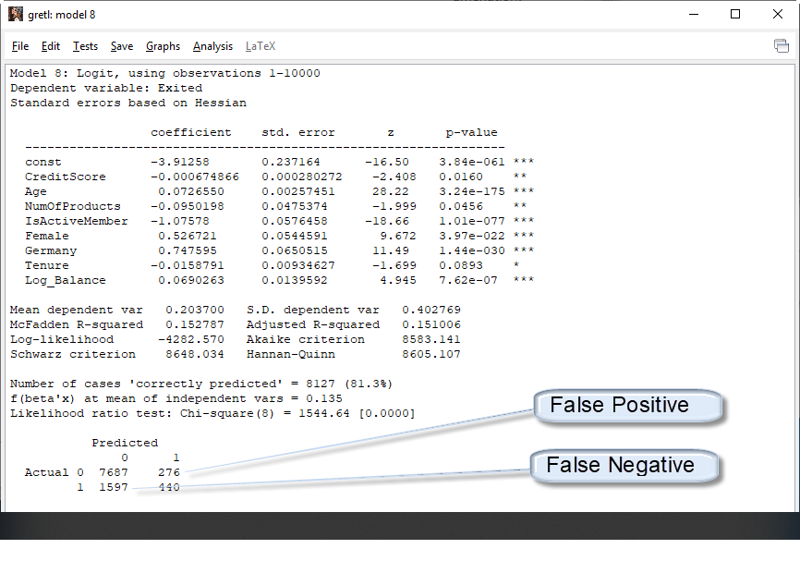

Figure - Confusion Matrix

From the confusion Matrix, the accuracy and error rates were calculated as shown below.

Accuracy Rate = Correct/Total = (7687+440)/10000 = 81.27 %

Error Rate = Wrong/Total = (276+1597)/10000 = 18.73 %

So this analysis showed that the accuracy rate based on the chosen independent variable and using the logistic regression algorithm gives us an accuracy rate of 81.27. This could be acceptable for a bank, because the accuracy or lack thereof might hist the banks bottom line, but it would not cause any harm to anyone (physical or financial). We would however have to reconsider our approach if the accuracy was detrimental to health and safety of people, animals or the environment. In those cases, we must deem 81.27% unacceptable and go back to data collection and analysis phase.

# Conclusion

Data analysis is an essential part of data science project. It involves deep understanding of the data, the domain of the data and all the statistical knowledge and know-how we can through at it. Without it, the outcome of the project will be inaccurate. Advances in technology will help shorten this cycle and lead to better and more beneficial outcome to the overall project. However for now and for the foreseeable future, this step will be among the first steps data scientists will have to take to begin the data science project.

References

1. Rahul Gupta,Michael Koffie,Brandon May,Tushar Muley,Edris Safari –“As The World Churns: Customer Data, Business Models, and Predicting Customer Trends and Behaviors”. Final project DSC500 Bellevue University
2. https://www.kdnuggets.com/2017/04/value-exploratory-data-analysis.html
3. Kelleher, John D. Data Science (MIT Press Essential Knowledge series) (p. 1). The MIT Press.